📁 File Details & Purpose
File | Type | Purpose
xgboost_fraud_detection_model.joblib | Model file | The core trained XGBoost classifier for fraud detection.
scaler.joblib | Preprocessing | StandardScaler (likely) for normalizing numerical features.
tfidf_vectorizer.joblib | Preprocessing | TF-IDF vectorizer for text-based features (e.g., transaction descriptions).
calibrated_fraud_system.pkl | Calibration | Possibly a post-processing calibrated model (e.g., CalibratedClassifierCV).
calibration_function.pkl | Calibration | Function or mapping to adjust raw model scores to calibrated probabilities.
feature_names.json | Metadata | List of feature names in the order expected by the model pipeline.
expected_adv_columns.json | Metadata | Column names expected in new/adversarial data for validation.
MODEL_USAGE_GUIDE.json | Documentation | Instructions for model loading, prediction, and interpretation.

🔧 How They Work Together
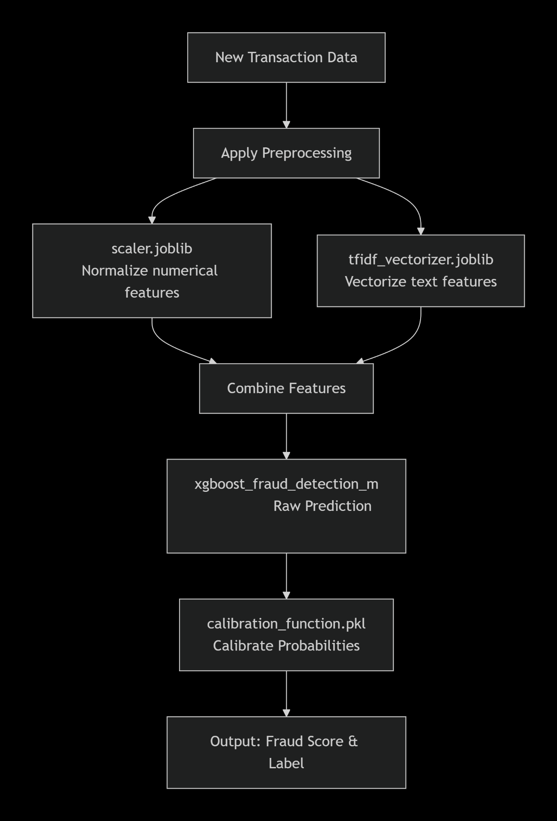

📘 Additional Documentation Notes

1. Feature Engineering & Schema
- feature_names.json – Use this to validate that incoming data columns match the trained model’s expected features.
- expected_adv_columns.json – Likely used to check for adversarial inputs or missing columns in production.

2. Calibration System
- calibrated_fraud_system.pkl may be a wrapped model that includes both the XGBoost model and calibration.
- calibration_function.pkl could be a sigmoid or isotonic calibration function from sklearn.calibration.

3. Preprocessing Chain
- Order matters: Apply tfidf_vectorizer before merging with scaled numerical features.
- Sparse vs. Dense: TF-IDF outputs sparse matrices; ensure compatibility when concatenating with scaled features.

4. Model Serving Considerations
- Memory: TF-IDF and XGBoost models can be large; monitor RAM in production.
- Versioning: Keep all files synchronized; changing one (e.g., scaler) without retraining the model may break predictions.

5. Expected Input Format
Example input row (JSON):
json
{
"amount": 150.75,
"transaction_description": "Payment to unknown vendor",
"user_age": 34,
"location": "NYC"
}

6. Output Format
The system likely returns:
json
{
"fraud_probability": 0.87,
"is_fraud": true,
"threshold_used": 0.5
}

⚠️ Common Pitfalls & Checks
- Column Mismatch: Compare incoming data columns with feature_names.json.
- TF-IDF Vocabulary: Ensure new text data doesn’t contain unseen tokens that could be ignored or cause errors.
- Calibration Threshold: The decision threshold (e.g., 0.5) may be tuned for precision/recall balance.
- Data Types: Scalers expect floats; vectorizers expect strings.

🛠️ Suggested Additional Files (If Missing)
File | Purpose
requirements.txt | Python dependencies (sklearn, xgboost, joblib, etc.)
inference_pipeline.py | Example script for batch/real-time prediction
config.yaml | Configuration for thresholds, API endpoints, logging
validation_schema.json | JSON Schema for input validation

